ICN Evaluation

Date: 15-June-2023

Submitted By: Vikhyat Bansal [CB.EN.U4AIE21076]

There will be two links for the recording as the CPT crashed during the work and had to restart.

Screenshot

Pinging in the same subnet: From PC2 to PC0

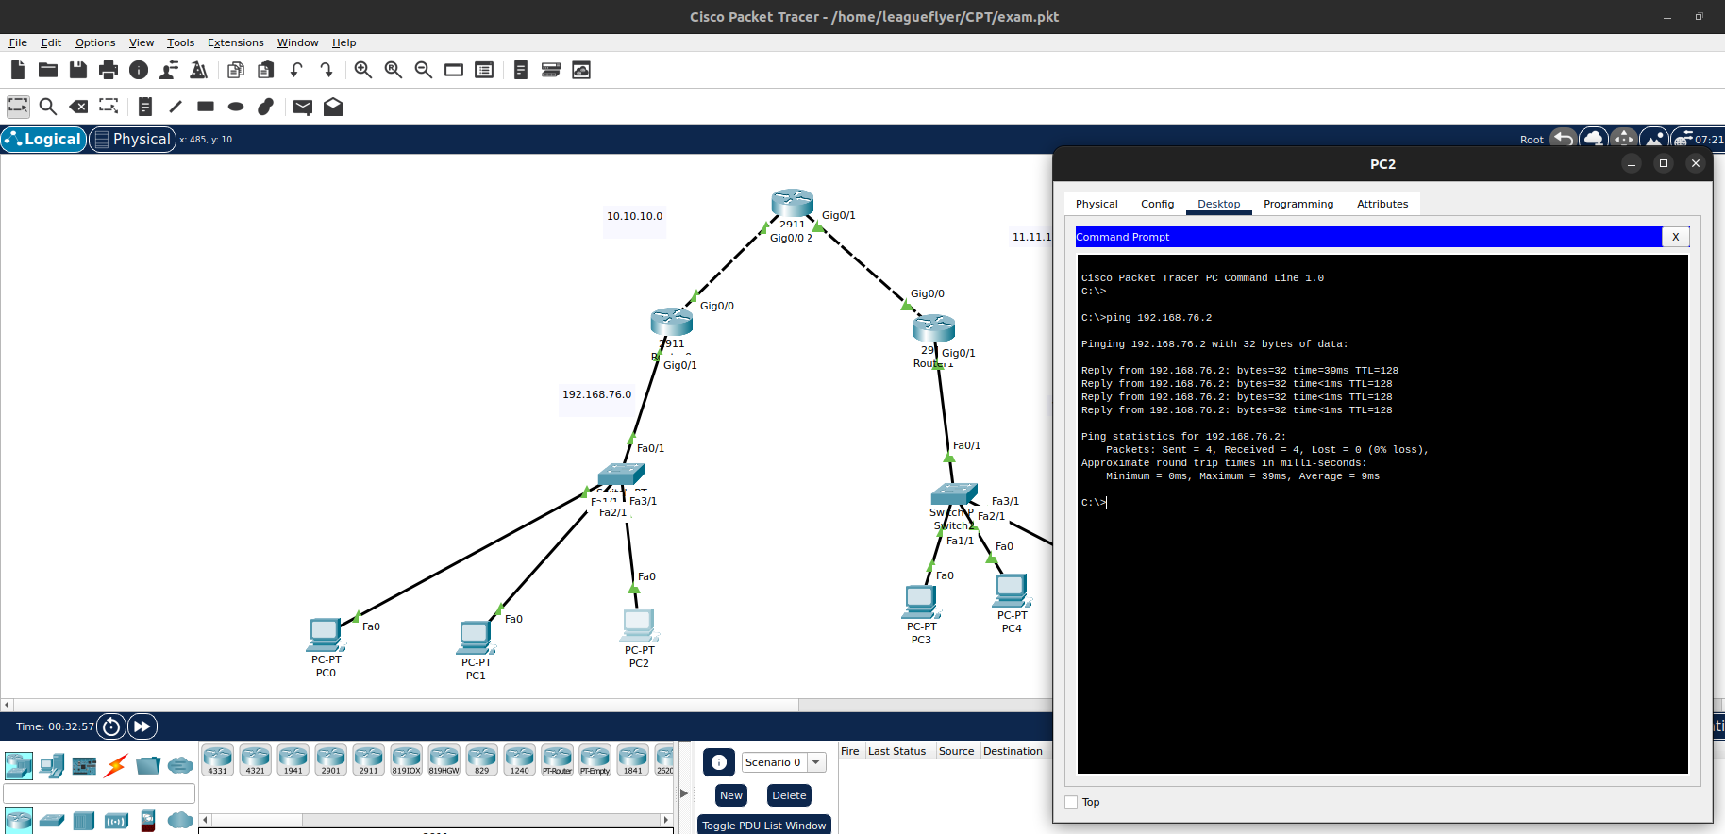

Pinging from one subnet of area 10 to another subnet of area 20

From PC1 to PC5

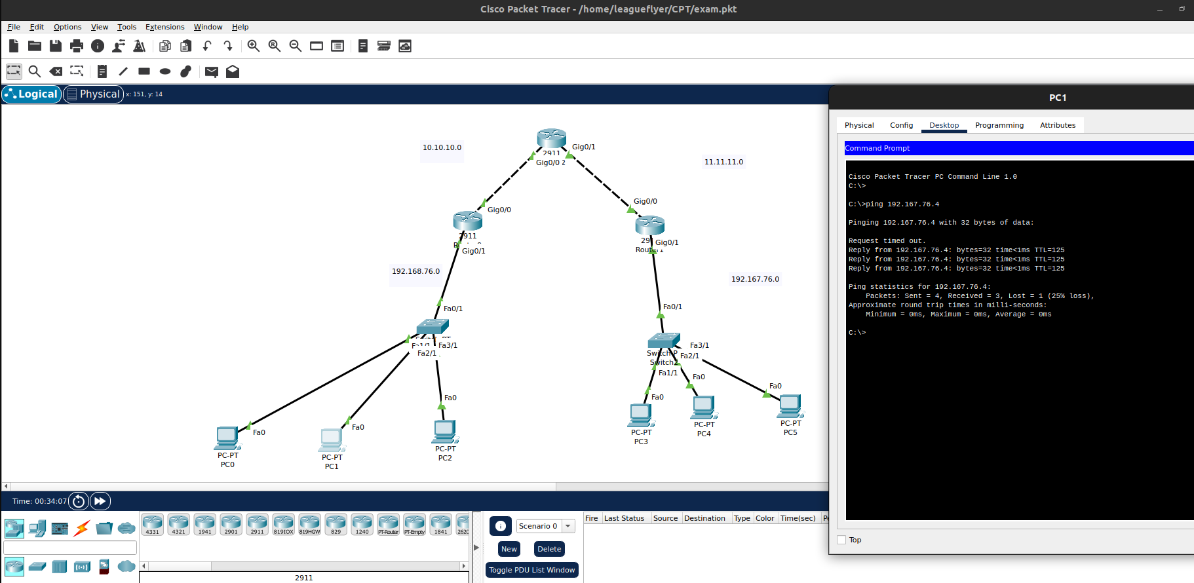

Pinging from subnet of area 20 to that of area 10

From PC4 to PC1

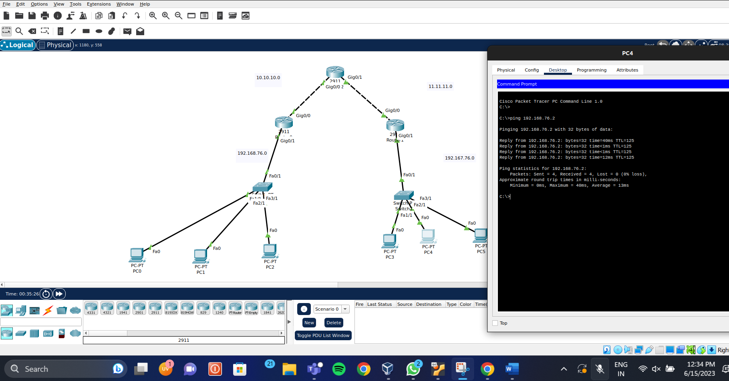

THANK YOU!!